DO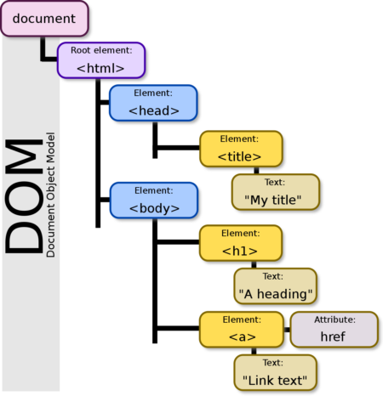M = DOCUMENT OBJECT MODEL

Validar email con expresiones regulares

https://emailregex.com